**Create a function – Exceptions**

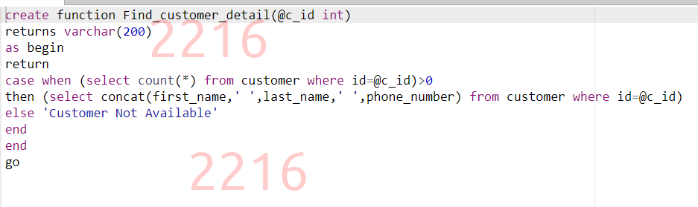

**NoOfYears Exception**

**Delete_status Exception**

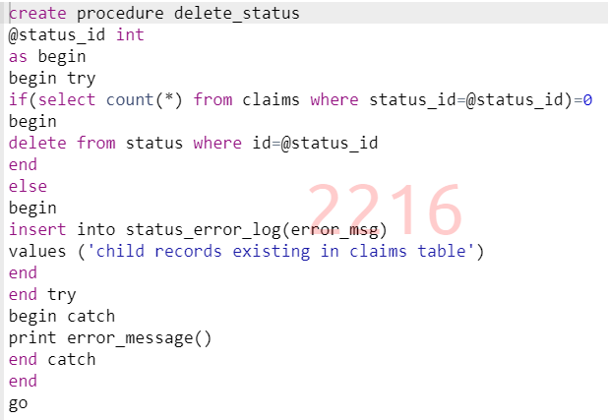

**Insert a new customer – Exception**

**Department Records using Cursors**

**Employee Records using Cursors**

**Insert_records – Triggers**

**Trigger – Claims**

**Update Records – Trigger**

**Insert Records – Trigger**

